NewWorkTech Co-Creation Framework
Easy-to-Read Summary


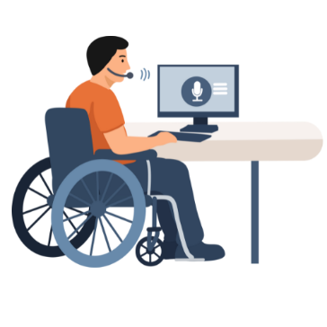
What is the NewWorkTech project about?
NewWorkTech is a project about work and technology. It focuses on persons with disabilities and their interaction with technology at the work place.

The project looks at how technology, such as Assistive Technology (AT) and Artificial Intelligence (AI), helps people at work.
It also researches how this technology can be improved.
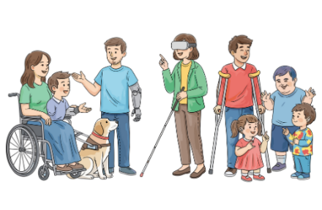
Who is the project for?
Persons with different disabilities are at the centre of the project.
They help make decisions. This follows the idea ‘Nothing about us without us’.
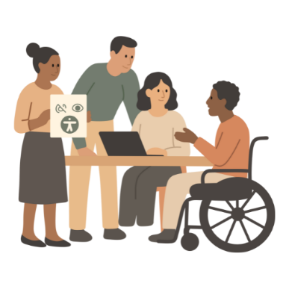
What are the aims of the project?
- To improve accessibility of the work places.
- To have technology that supports the real needs of persons with disabilities.
- To make technology easier to use.
- To reduce inequality.
- To improve the work capabilities of everyone.


What is this document about?
This document explains the co-creation guidelines used in the NewWorkTech project.
It is called a Co-Creation Framework. It gives steps to follow when creating something for persons with disabilities. Like technologies.

What is co-creation?
Co-creation means creating something together.
Different people work together as a team.
Everyone can share ideas.
Everyone can help make decisions.

Who takes part?
In the NewWorkTech project, co-creation includes:
- Persons with different disabilities;
- Organisations supporting and representing persons with disabilities;
- Professionals (for example, IT experts);
- Policy makers.
All people have an equal say in the process.
How does co-creation work?

People talk and listen to each other. They share their experiences. They say what they need and what works for them.
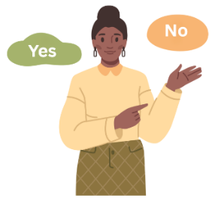
Decisions are made together, not by one person alone.
In NewWorkTech, persons with disabilities share their experience with technology at work. They know best which technology helps them and which technology does not help them.

This information helps improve and create new technologies. This way, persons with disabilities who use technology help design it.

Why is co-creation important?
Co-creation is important because:
- People feel heard and respected;
- Solutions fit real needs better;
- Everyone’s experience matters;
- The result is more useful and fair.
What is the NewWorkTech Co-Creation Framework?

The NewWorkTech Co-Creation Framework helps us understand:
- How people with different abilities use technology;
- What people need when they use technology;
- What works well and what does not work well.
The Co-Creation Framework gives clear steps how to do that.

The Framework is based on a method called Design Thinking.
Design Thinking means:
- Putting people first;
- Understanding people’s feelings and needs;
- Testing ideas;
- Improving ideas step by step.
This method is good for creating technology that supports people with disabilities. It is based on five phases. They are:

- Empathy
This is listening to how persons with disabilities feel when they use technology at work. This is also about finding out what makes things hard for them.
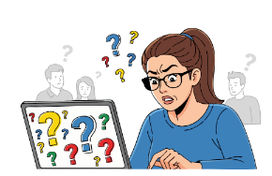
- Defining the problem
The aim is to identify and address the needs of the people who use the technology.

- Ideation (idea-making)
The involved people share ideas that can improve how technology is used at work.


- Prototyping
This steps is about looking at and working with the ideas from the earlier discussions. It helps to turn discussion ideas into clearer solutions.

- Testing
In this step, people with disabilities test the ideas and solutions previously discussed. They check if the technology works well for them and say what is helpful, and what needs to change.
Each phase helps understand needs and improve technology.
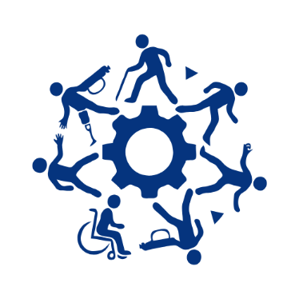
Summary
The NewWorkTech Co-Creation Framework puts people with disabilities in the forefront.
It helps create technology that is inclusive and that works well for everyone.

Easy-to-read text by Panita Ball, Projects and Events Officer, European Platform for Rehabilitation (EPR)
To access the full NewWorkTech Co-Creation Framework Document, click here: https://www.newworktech.eu/co-creation-framework
For more information about Easy-to-read, see Inclusion Europe’s website: https://www.inclusion-europe.eu/easy-to-read/

-----------------
NewWorkTech Co-Creation Framework
Authors: Tiziana Guzzo and Maria Chiara Caschera, Researchers at the National Research Council (CNR), Institute for Research on Population and Social Policies (IRPPS)

