NewWorkTech Manual Work Dataset
Easy-to-Read Summary


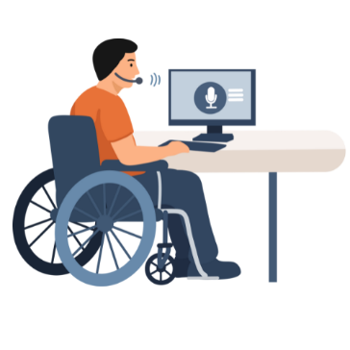
What is the NewWorkTech project about?
NewWorkTech is a project about work and technology. It focuses on persons with disabilities and their interaction with technology at the work place.

The project looks at how technology, such as Assistive Technology (AT) and Artificial Intelligence (AI), helps people at work.
It also researches how this technology can be improved.
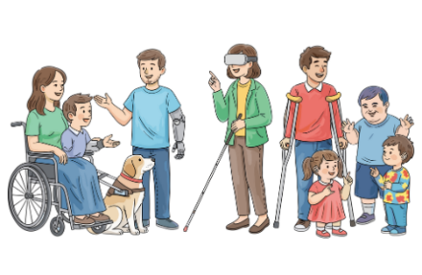
Who is the project for?
Persons with different disabilities are at the centre of the project.
They help make decisions. This follows the idea ‘Nothing about us without us’.
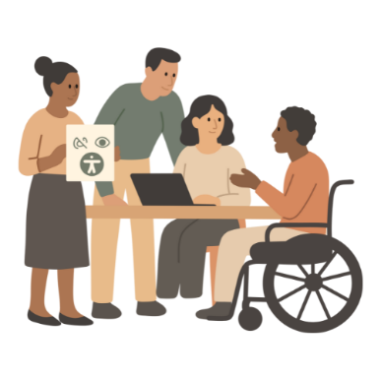
What are the aims of the project?
- To improve accessibility of the work places.
- To have technology that supports the real needs of persons with disabilities.
- To make technology easier to use.
- To reduce inequality.
- To improve the work capabilities of everyone.
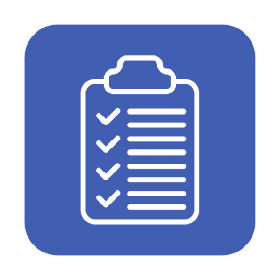
What is this document about?
This document explains how people with disabilities do manual work and what helps them. It is called the Manual Work Dataset.
It explains what helps people work well, like support from other people and tools.
Manual work means you have to be at a work place to do the job.
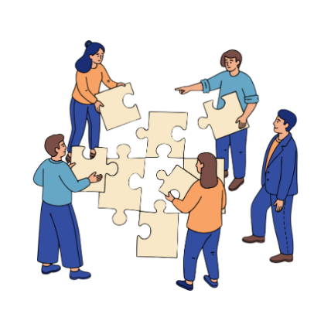
What is the goal?
To find out how people do their jobs.
What helps them.
What makes work hard.

Who took part?
- Persons with learning disabilities;
- Autistic persons and with ADHD;
- Persons with physical disabilities;
- Persons with mental health conditions.
Where did this happen?

The study happened in:
- Italy;
- Germany;
- Finland.
What kind of jobs were studied?
Some examples of jobs studied include:
- Shops and cafes;
- Cleaning and jobs that help move things;
- Museums and Kitchens;
- Work with beauty and care.
What information was collected and how?
Researchers watched how people do their work and what problems they face.
They did this with:
- video and audio recordings;
- taking pictures;
- watching and taking notes and;
- doing interviews.
People’s personal information is kept private.
The law tells us to do this.

What support did workers use?
They asked for help from their colleagues or job coaches.
People used tools like checklists, workboards, and printed guides.
These guides were written in Easy-to-Read language.
They used technology to help them work.
This included barcode scanners and mobile phones.
What problems do workers face?
People with disabilities face problems at work.
For example:
- Workplaces are not fully accessible;
- Support is needed from others or tools;
- Some difficulties with tasks or instructions;
- Training does not fully fit their needs;
- Some difficulties with communication;
- Their mental health affect their work.

How are these problems solved?
The problems are solved in these ways:
- Other people help when needed;
- Tasks are organised to fit the person;
- The workplace is organised to fit the person;
- Simple tools and training are provided.
What researchers learned so far
People can work well | Many people work very well when the job fits their needs.
Support matters | Support from people or tools makes work easier.
Simple tools help | Checklists and clear instructions are very useful.
Feeling valued | Feeling respected and included is important at work.
Right environment | The workplace needs to be adjusted for the person.

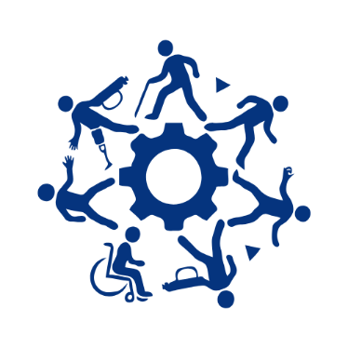
Summary
The key messages from this study are:
Inclusion works | People with disabilities can work successfully.
Support makes the difference | Work is easier when the workplace gives the right support.
Technology helps | Simple technology can remove barriers.
Listen to people | Nothing about people without involving them.

Easy-to-read text by Panita Ball, Projects and Events Officer, European Platform for Rehabilitation (EPR)
To access the full NewWorkTech Manual Work Dataset, please click here.
For more information about Easy-to-read, see Inclusion Europe’s website: https://www.inclusion-europe.eu/easy-to-read/

-----------------
NewWorkTech Manual Work Dataset Authors
Authors: Maija Hirvonen (P.I.), Tampere University Brian Due (P.I), University of Copenhagen Dorothée Kraus, Tampere University Annamari Korhonen, Tampere University Sara Merlino, University of Copenhagen Barbara Carreras, University of Copenhagen

